<!DOCTYPE html>

<html lang="en">

<head>

    <meta charset="UTF-8">

    <meta name="viewport" content="width=device-width, initial-scale=1.0">

    <title>Document</title>

    <style>

        body{

            margin-left: 100px;

        }

    </style>

</head>

<body>

    <h1 style="text-align: center;">HTML Assingnment 1</h1>

    <hr color="red">

    <h>if is my <b>First HTML</b> Assingnment.I am exited to learn HTML, and i want to make in <b>web designing.</b></h>

<h1><b>Introduction to HTML</b></h1>

<h>HTML <I>(Hypertext Markup Language)</I>is used to creat Document on the <u>world wide web.</u><i>it is simply a collection of certain

    key words called <q>Tahs</q>that are helpful in writing the document to be displayed using a browser<br>

     on Internet</i>.HTML WAS developed by <b>Tim Berners-Lee </b>in 1992.</h1>

</body>

</html>

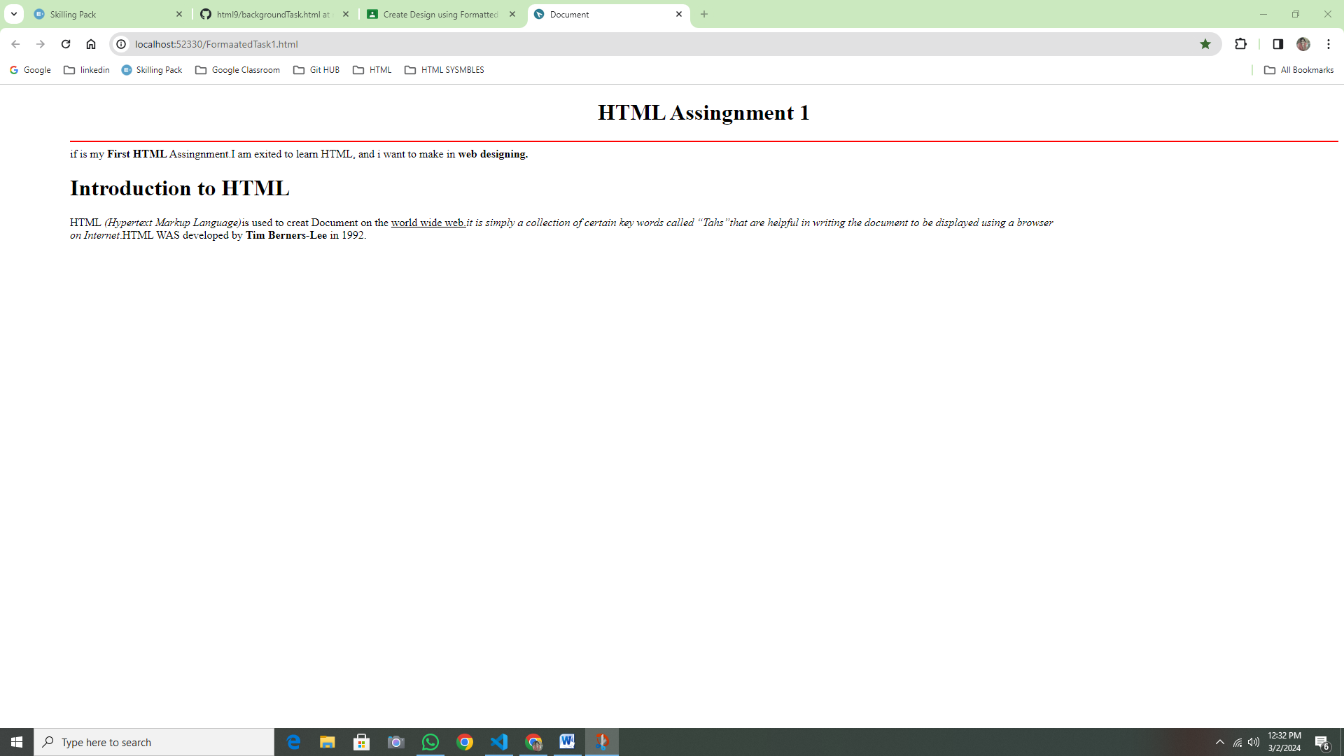

<!DOCTYPE html>

<html lang="en">

<head>

    <meta charset="UTF-8">

    <meta name="viewport" content="width>, initial-scale=1.0">

    <title>Document</title>

    <style>

        body{

            margin-left: 100px;

        }

    </style>

</head>

<body>

    <h3 style="text-align: center;"> <U>QUESTION PAPER FOR SUMMATIVE TEST  - &#8545;<BR>MATHEMATICS<BR>CLASS-&#8551;</U></h3>

        <h><dd>Maximum Marks: 20</dd></h>

            <h3><b><dd>General instructions:</b></dd></h3>

            <ol type="1">

                 <li>All Question are compulsory</li>

                 <li>The question paper consist of 7 questions divided in to 2 sections A and B</li>

                 <li>Section A contains 4 question of 2 marks each</li>

                 <li>Section B contains 3 question of 4 marks each</li>

            </ol>

                 <h3 style="text-align: center;"><U>SECTION A</U></h3>

                 <h>Q1- What will be the product of (a<sup>2</sup>)x(2a<sup>22</sup>)x(4a<sup>26</sup>)</h>

                    <ol type="a">

                    <li>8a<sup>46</sup></li>

                    <li>8a<sup>48</sup></li>

                    <li>6a<sup>50</sup></li>

                    <li>8a<sup>50</sup></li>

                    </ol>

      <h> Q2- Water is qxidised to oxygen by (a<sup>2</sup>)x(2a<sup>22</sup>)x(4a<sup>26</sup>)</h>

                    <ol type="a">

                    <li>H<sub>2</sub>O<SUB>2</SUB></li>

                    <LI>KMnO<SUB>4</SUB></LI>

                    <LI>CIO<SUB>2</SUB></LI>

                    <LI>Fluorine</LI>

                    <h4 style="text-align: center;"><del>Cutting is Not Allowed</del> Select Only one Option</h4>

                    </ol>

</body>

</html>

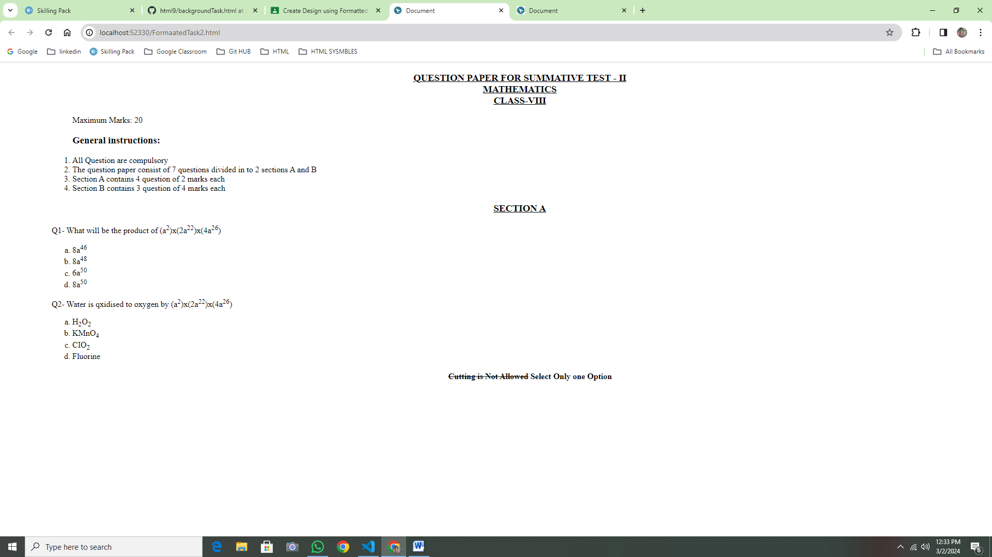

<!DOCTYPE html>

<html lang="en">

<head>

    <meta charset="UTF-8">

    <meta name="viewport" content="width=device-width, initial-scale=1.0">

    <title>Document</title>

    <style>

        body{

            margin-left: 100px;

        }

    </style>

<body>

    <h3 style="text-align: center;"><u>List of Courses</u></h3>

    <h3>Certificate Courses</h3>

    <ul style="list-style-type: square">

    <LI>CSS</LI>

    <LI>DTP</LI>

    <LI>TALLY</LI>

</ul>

    <h3>NIELIT Courses</h3>

    <ol type="I">

    <li>CCC</li>

    <LI>O Level</LI>

    <li>A Level</li>

    </ol>

    <h3>NIELIT Courses</h3>

    <ol type="A">

    <LI>DCA</LI>

    <LI>ADCA</LI>

    <LI>DFA</LI>

    <LI>DDNT</LI>

    </ol>

    <h3>Programing Courses</h3>

    <ol start="11">

        <li>PYTHON</li>

        <li>JAVA</li>

        <li>C Programing</li>

        <li>C++</li>

        <li>Data Structure using C</li>

    </ol>

        <h3>Web designing Dourses</h3>

        <ol type="A">

            <li>HTML</li>

            <li>CSS</li>

            </ul>

        </ol>

</body>

</html>

